[Company Name]

[Draw your reader in with an engaging abstract. It is typically a short summary of the document. When you’re ready to add your content, just click here and start typing.]
User’s Guide
BMS Link Wholesaler

Table of Contents
New customers 2
Manage customer records 4
Create Order 7
Create order in Kanban view 10
Create order in List view 10
View Order 11
Kanban view 11
List view 11
Edit/Update Order 12
Edit/Update in Kanban View 12
Edit/Update in List View 13
Delete Order 14
Multiple orders 14
Single order 15
Delete order item 15
Change Order Status 16

New customers
Customers > [Add Customer]

This is the form used to register new customers and add them to your customer database.
1

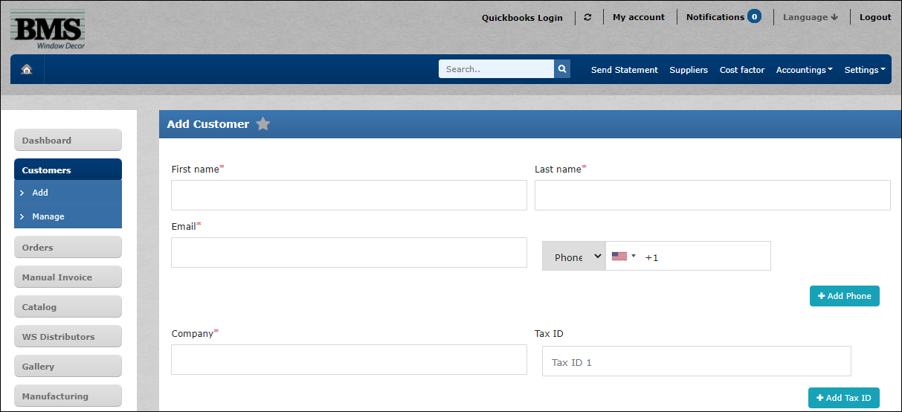
2

3

4

- Enter customer’s name. Both first and last name are required.
*Only alphabets are accepted.
- A valid email address is required.
- Key in the phone number, fax or mobile (include the country code).
[+Add Phone] Option to add more than 1 number.
- Enter company name.

6

5

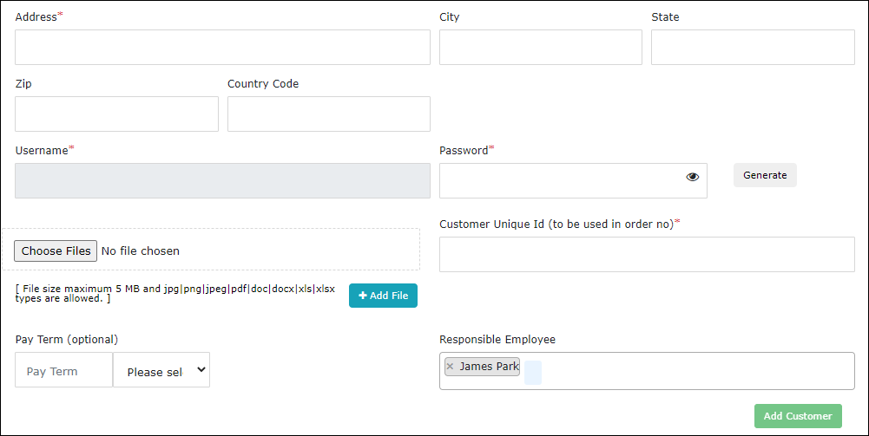
8

7

9

- Enter a valid address in this field. The City, State, Zip code and Country Code fields are automatically populated once done.
- A password is required for your login.
[Generate] The system will generate a password for you.
Click this icon to reveal the password.
- Attach a file no larger than 5 MB in size.
[Choose Files] Browse to choose the file to upload.
[+ Add file] A maximum of 4 files can be added.
- Select an employee name.
- [Add Customer] Submit customer details into the system.

Manage customer records
Customers > [Manage]
Manage your customer list with options to export customer details to a file.

2

1

3

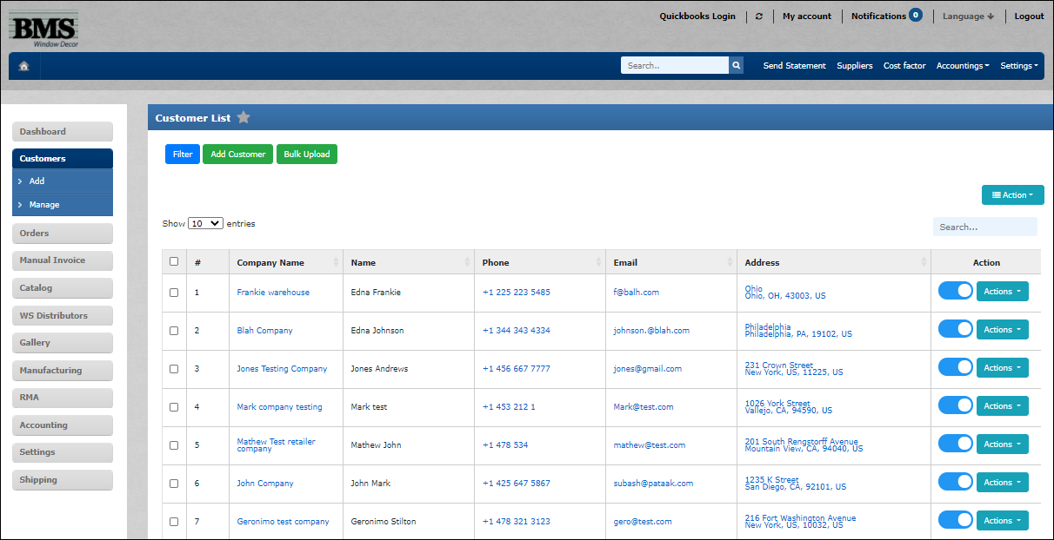
6

5

4

- Select to view customers based on Company Name, Phone, Email or Address.

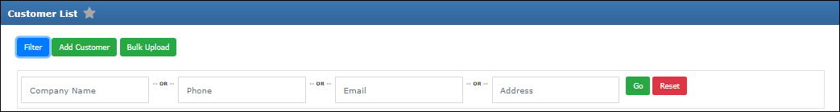

- To add a new customer, refer to [Add Customer].
- If you have multiple customers to add, you can upload a file containing customer details following the header format given in the sample file.

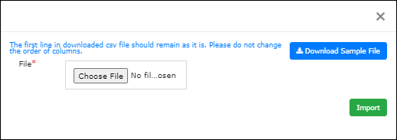
ii

i

iii

- You can download and use this sample file to fill in customer details. Save this file in .csv format.
- Choose the .csv file to be uploaded.
- Submit the customer file list to be imported into the database.
- Click this button to access options to export or delete customer records or send pending invoices to customer.

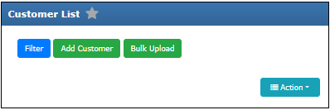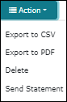
ii

i

- Choose to export customer records to a report file in either .csv or .pdf format.
- Send pending customer invoice to selected customer from the list.
- Access a customer record using shortcut links through Company Name, Phone, Email and Address.
- Access features to Auto Login, View, Edit, View Statement, Send Statement and Delete customer record.

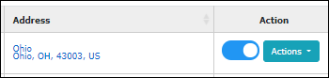
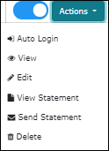
ii

i

- Access customer profile by automatically logging into the customer portal.
- Click to view selected customer’s statement of pending invoices.
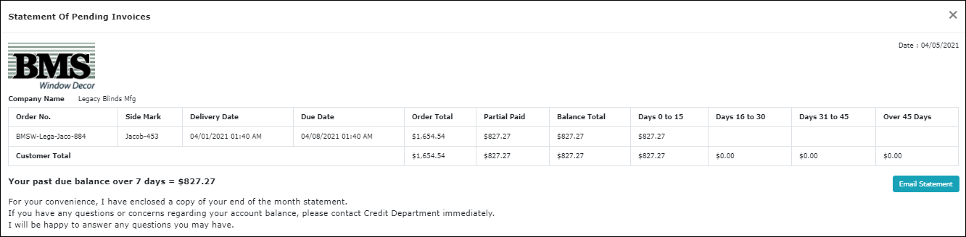

Create Order
Order > [New]
Create new customer orders.
1

2

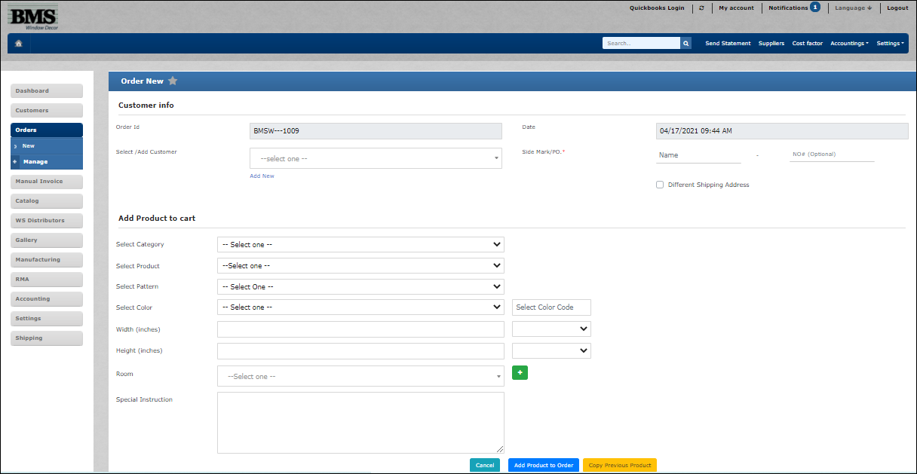
4

3

- Fill in customer’s details.
[Add New] New customers can be added by clicking on this link. Refer to [New customers] on how to add new customers.
- The Order ID is an auto-populated field following this format:
BMSW-Xxxx-Yyyynnn

Using this example BMSW-Suzi-Arch-987, the table below explains the format used.
a | BMSW | Refers to the first four characters of the wholesaler’s company name. E.g. BMSWindow Decor
b | Suzi | Refers to the first four characters of the customer’s name.
c | Arch | Refers to the first four characters taken from ‘Side Mark’ input.
d | 987 | Auto-generated billing number.

- If the shipping address differs from the default, you can add another address on this form.
- When filling in the product details, choose the Category first, followed by Product and follow through the next fields in sequence from top down.
Note: A new Category can be created under the Catalog menu. Refer to Catalog.

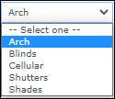
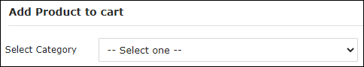

Once all order details are entered correctly, click on [Add Product to Order] button to view the summary of the order details as shown in Figure 1. More items can be added to the order following step #4 above.
Note: If more of the same product item is required, you can easily increase the quantity under Order Details (Refer to step #5).
5

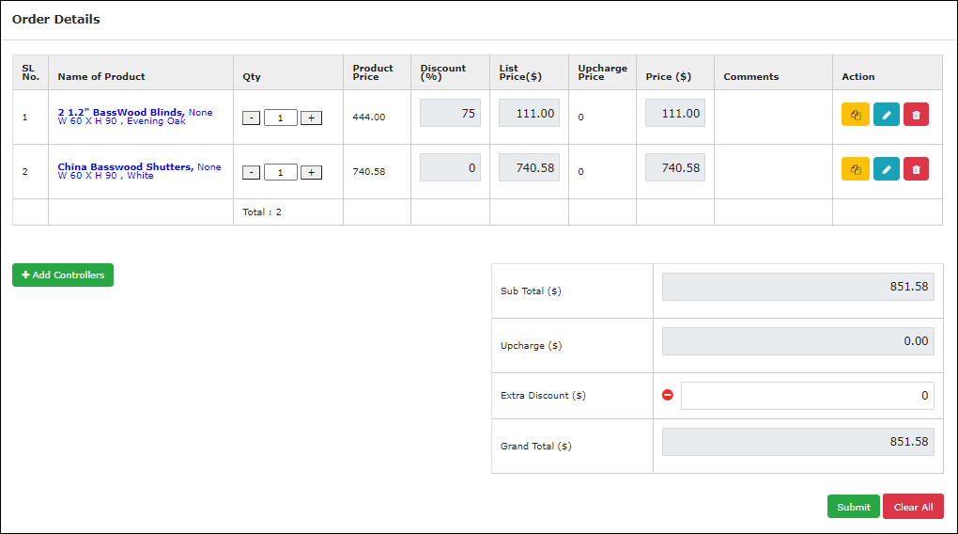
6

7

Figure 1
- Increase or decrease the quantity of the same product item here.
- Options are available to duplicate, edit or delete any product items.
- Submit your order as a final step of the new order process. A message pop-up will appear to confirm the order. Click [Yes] to proceed.
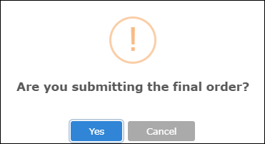

- Final order is as shown in Figure 2.
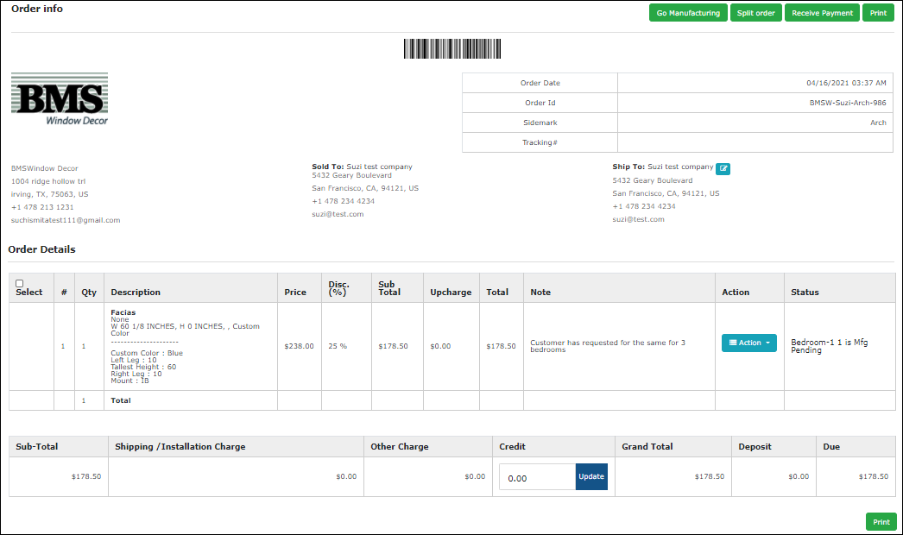
i

ii

Figure 2
- You can view, edit or delete a customer’s order items.
- A printout of the order appears as in Figure 3.

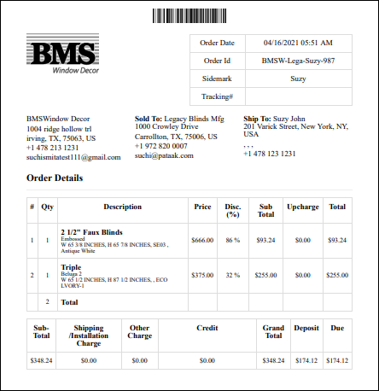
Figure 3

Create order in Kanban view
Order > [Manage] > Kanban View
You can create new orders in Kanban view.
1

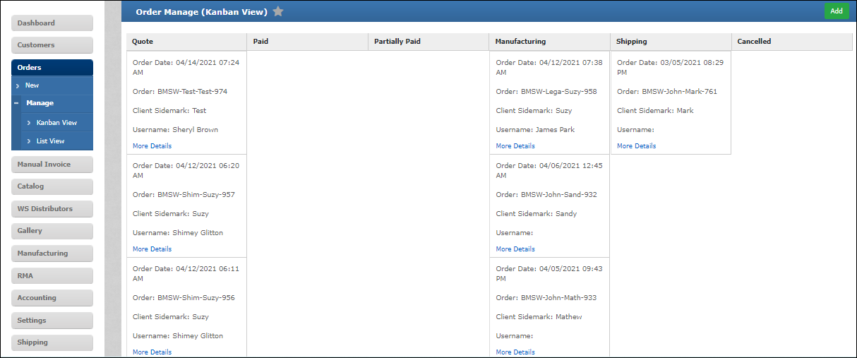
- Click [Add] to create a new order.

Create order in List view
Order > [Manage] > Kanban View
List view provides an option to create new orders.
1

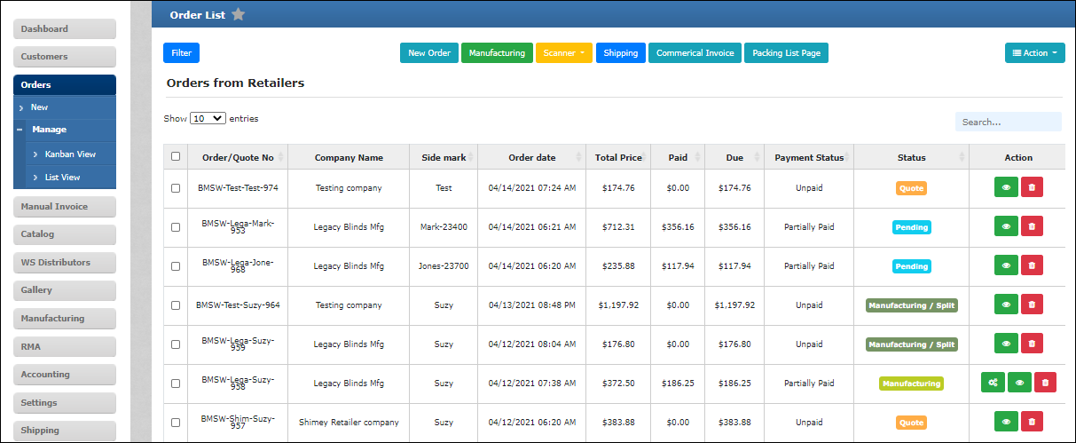
- Click [New Order] to create a new order.

View Order

Kanban view
Order > [Manage] > Kanban View
Customer orders are displayed by their order status.
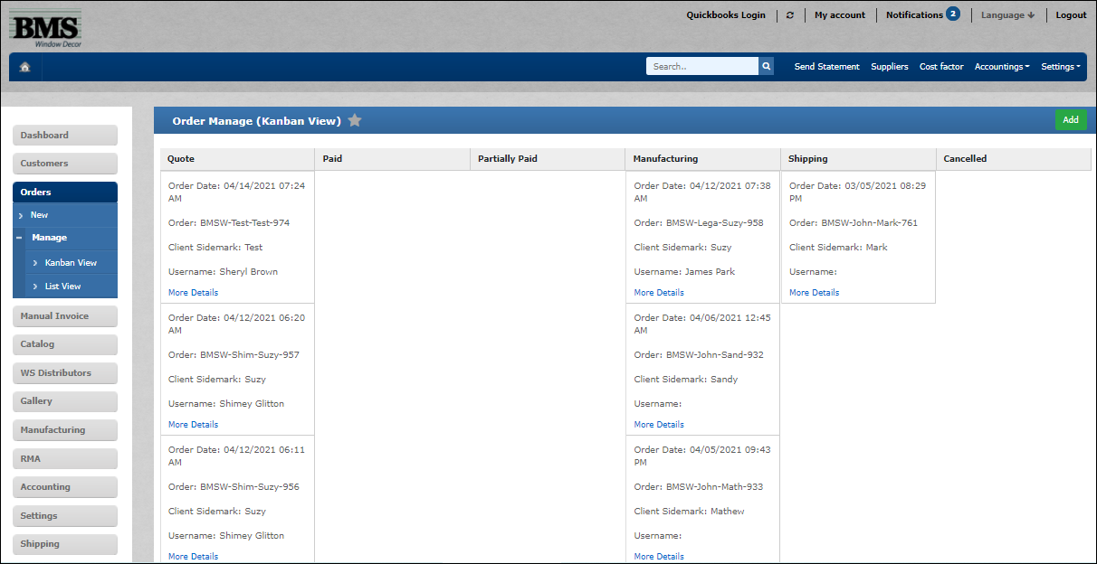

List view
Order > [Manage] > List View
Customer orders are displayed by their order number, top-down.
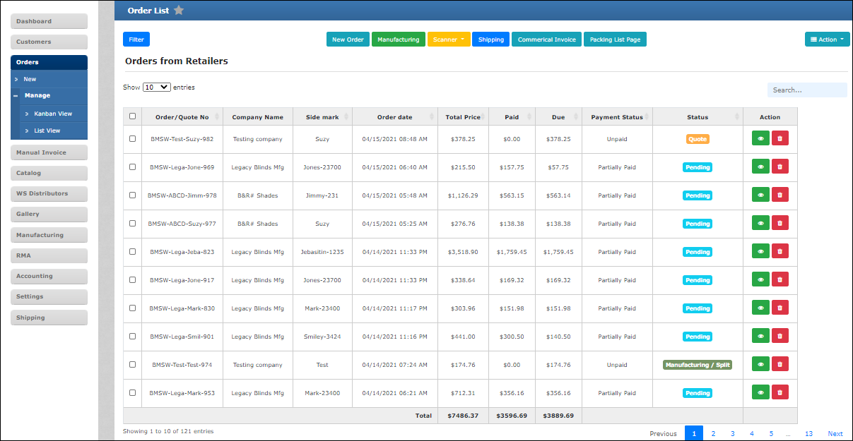

Edit/Update Order

Edit/Update in Kanban View
Order > [Manage] > Kanban View
Access customer’s order details in Kanban view to edit/update it.
1

- Click to view customer order details and proceed to update it as in Figure 2.
Proceed to edit the product details in the window pop-up as shown in Figure 4 and submit the changes once completed.

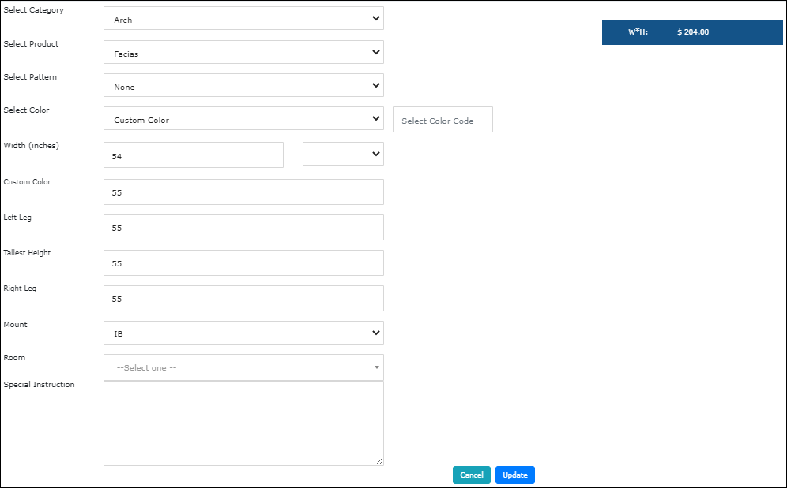
Figure 4

Edit/Update in List View
Order > [Manage] > List View
Access customer’s order details in List view to edit/update it.
1

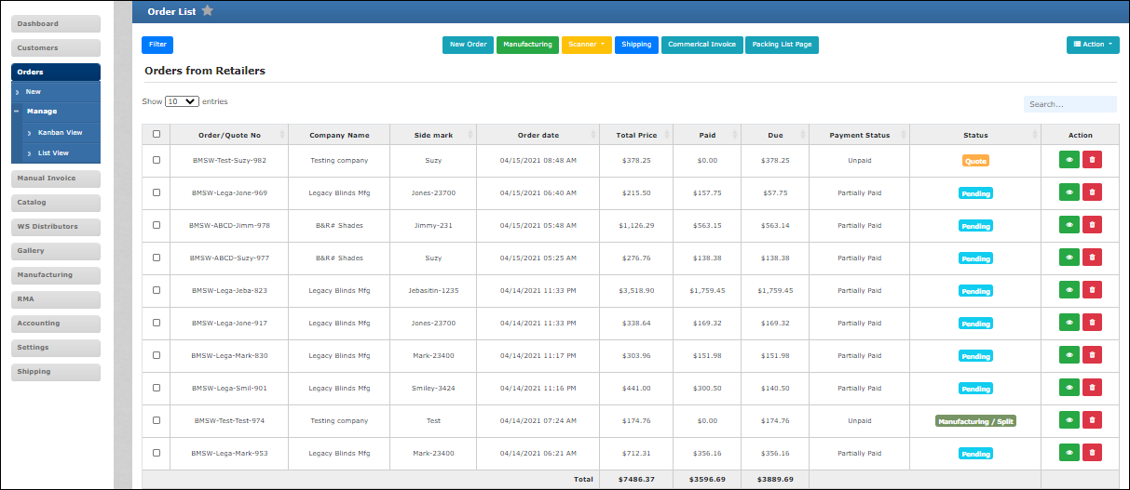
- Click to view customer order details and proceed to update it as in Figure 2.
Proceed to edit the product details in the window pop-up as shown in Figure 4 and submit the changes once completed.

Delete Order

Multiple orders
Order > [Manage] > List View
Delete multiple customer orders.
1

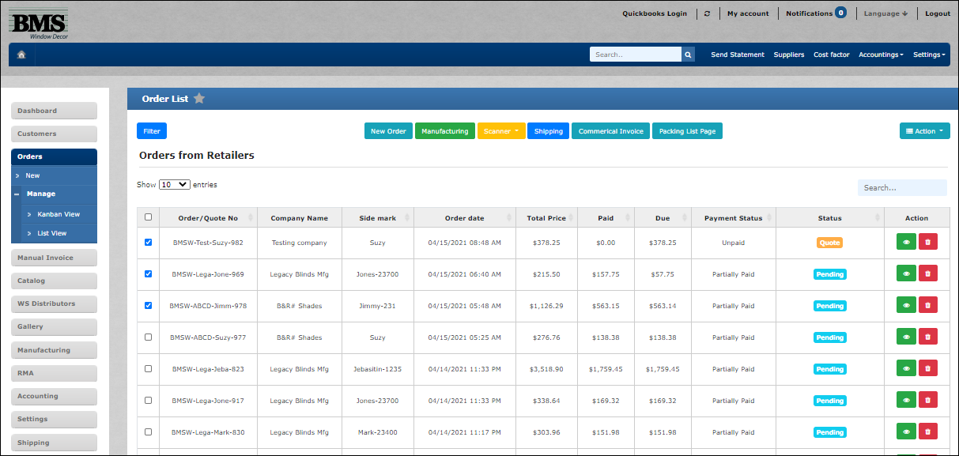
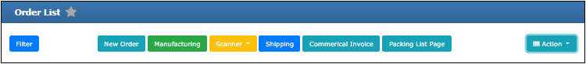
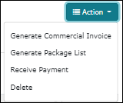
i

- Select customer orders to delete.
- Delete selected orders.
Note: A message pop-up will alert you for choosing different customers. Click OK to proceed.
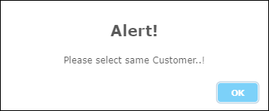

Single order
Order > [Manage] > List View
Delete individual orders.
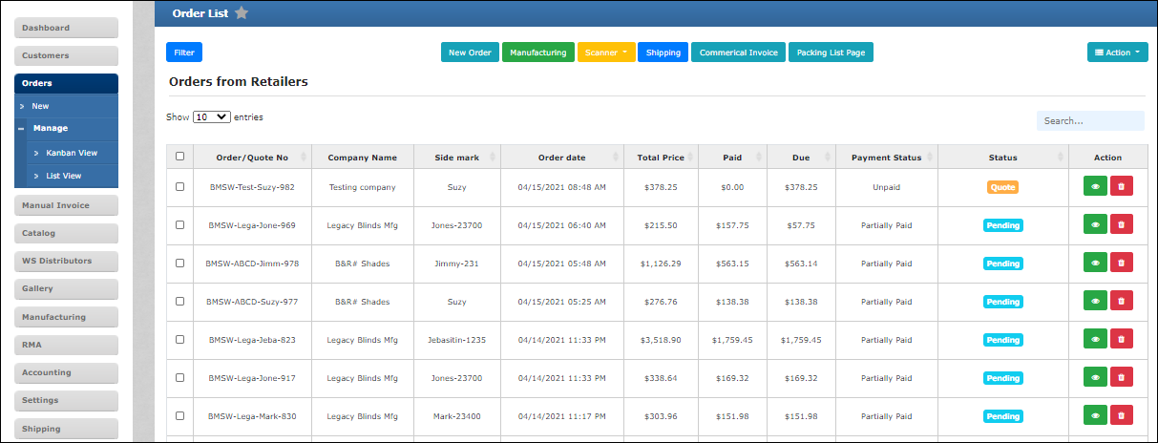
1

- Click here to delete an individual order.

Delete order item
Order > [Manage] > List View
Delete individual product items.
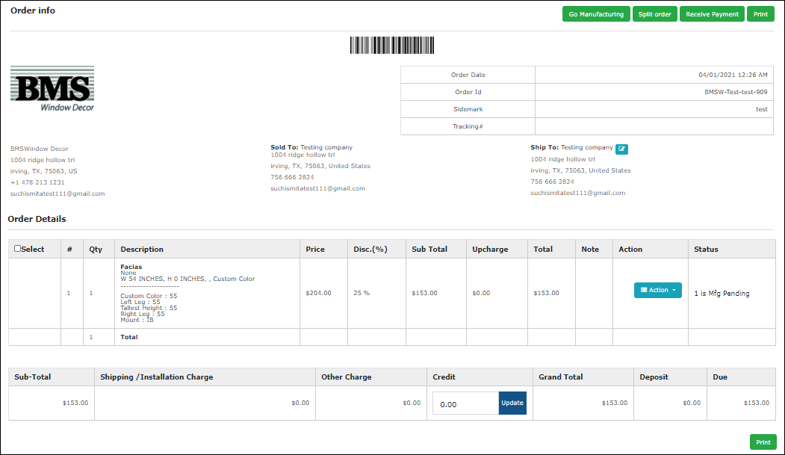
1

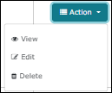
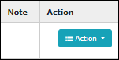
i

- Click here to delete individual product items.
- Once deleted, a message pop-up will appear to confirm action. Click OK to proceed.

Change Order Status
Order > [Manage] > List View
Manually change order status.
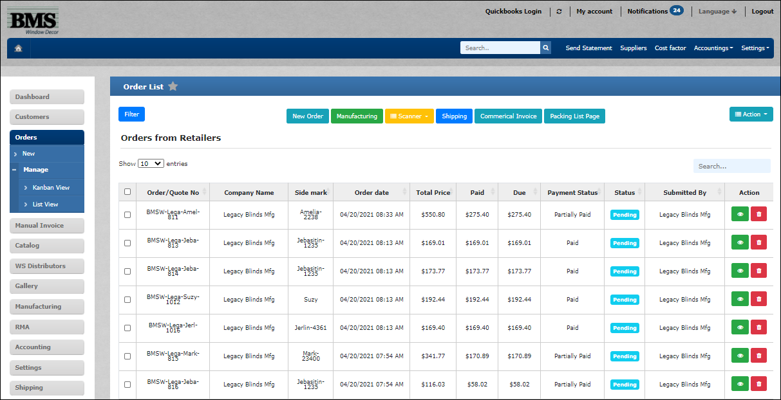
1

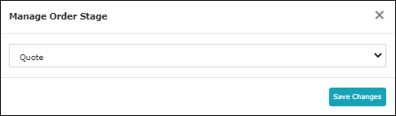

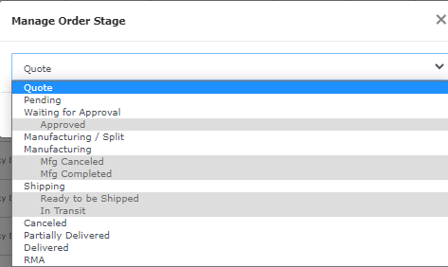

- Set the status of any customer orders manually.
Note: Order status that are greyed-out are excluded from selection.

